Supplementary File, FIGURE S1. Map of sampling locations for Pyropia vietnamensis in the Konkan region, India.
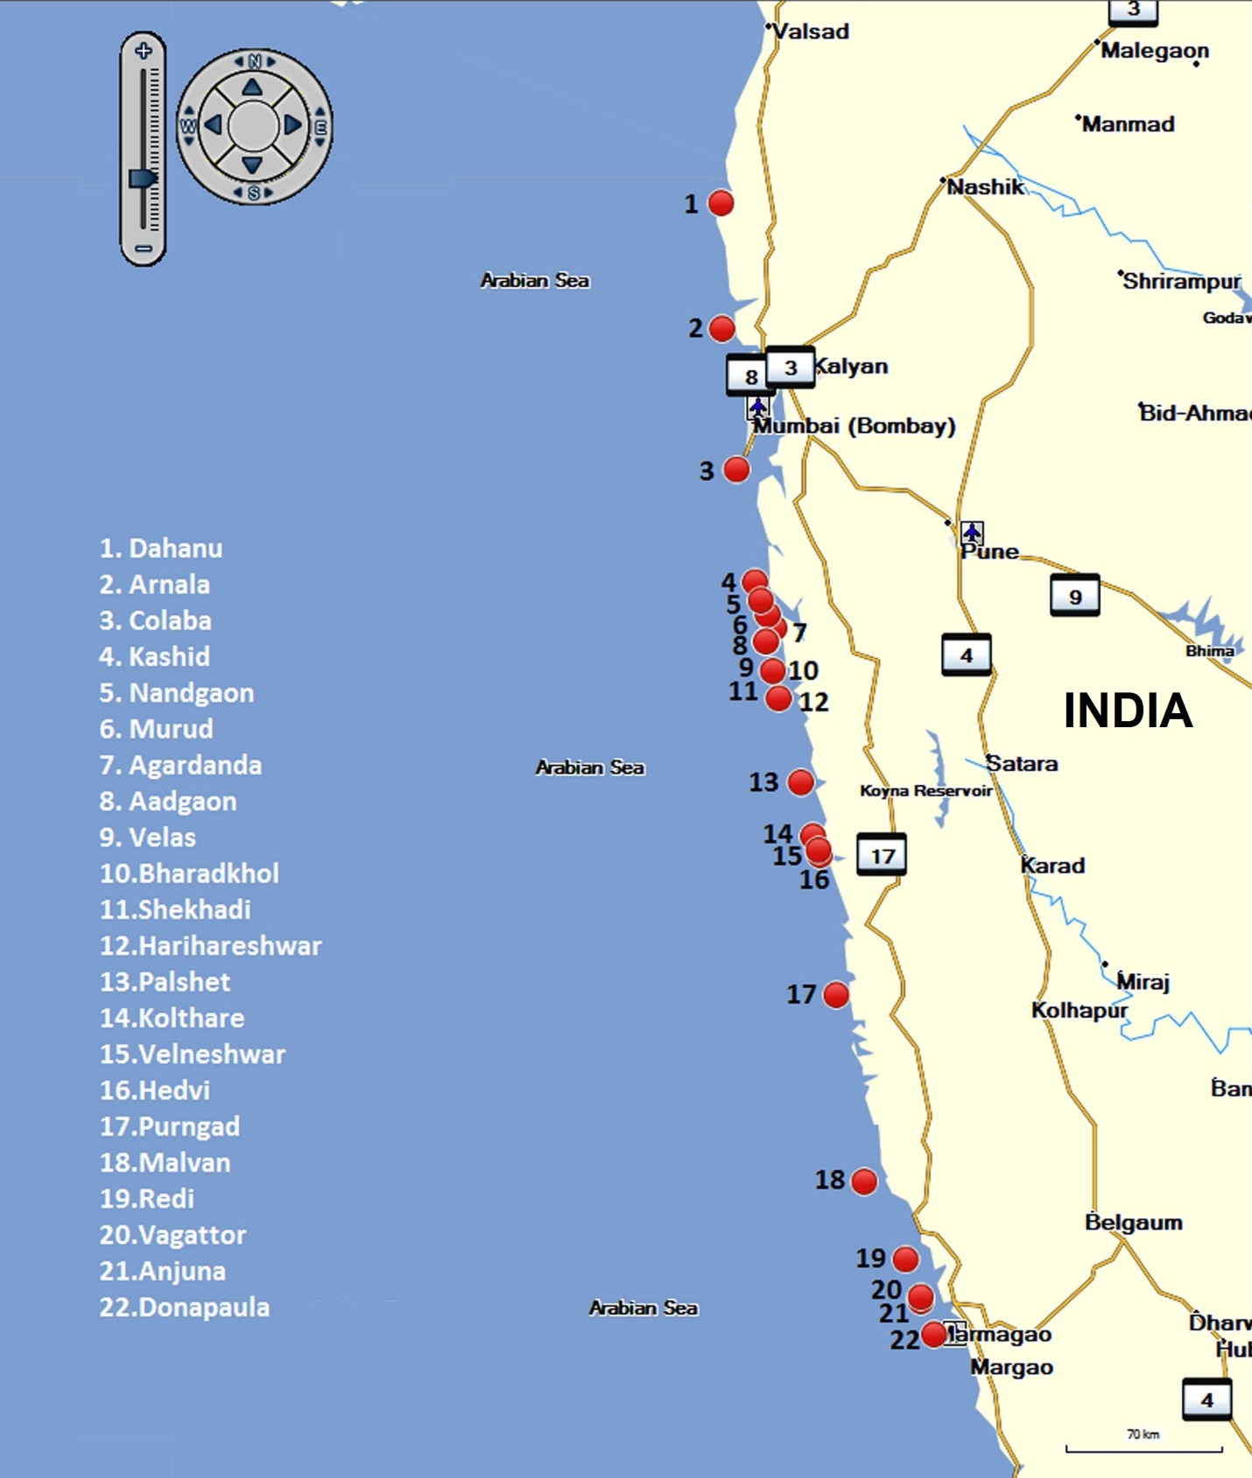

Supplementary File, TABLE S1. Collection sites, ecological variables, specimen collection number and GenBank accessions.
Collection site | Geomorphology of collection sites | Latitude and longitude | Specimen collection number | GenBank Accessions for cox1 gene | Salinity (psu) | Temp.  (°C)
Dona Paula | Rock laterite intermixed with columnar basalt, surface is even and porous but at places interrupted by water pools and huge boulders | 15° 27.135’ N  73° 48.191’ E | ARC-P-183 | KM977740 | 28.4 | 25.9±0.44
Anjuna | Rock laterite as well as basaltic and porous, many eroded boulders, water pools are scattered here and there along the rock surface surface is uneven due to crevices | 15° 35.083’ N  73° 44.213’ E | ARC-P-192 | KM977741 | 29.1 | 28.1±0.86
Vagator | Basaltic rock covered with coarse sand, uneven surface due to several cracks and crevices, | 15° 36.083’ N  73° 44.213’ E | ARC-P-196 | KM977744 | 28.4 | 28.4±0.98
Redi | Rock laterite and porous with cracks, crevices and water pools, sand deposition is found all along the beach | 15° 45.078’ N  73° 39.671’ E | ARC-P-73 | KM977739 | 19.1 | 26.1±0.79
Malvan | laterite and porous rock in northern part, vertically cut, columnar basaltic rock at sloppy region of western part , steep slope and sandy region in southern part | 16° 03.663’ N  73° 27.373’ E | ARC-P-48 | KM977736 | 30.2 | 26±0.35
 |  |  | ARC-P-69 | KM977738
Purnagad | soft as well as hard basaltic rock, unevenly eroded with cracks and numerous water pools | 16° 48.439’ N  73 18.709’ E | ARC-P-21 | KM977742 | 19.9 | 28.9±0.55
 |  |  | ARC-P-22 | KM977750
Hedavi | Basaltic rock with more or less even surface | 17° 22.016’ N  73° 13.591’ E | ARC-P-20 | KM977749 | 19.18 | 28.6±0.70
 |  |  | ARC-P-12 | KM977747
Velaneshwar | Basaltic rock with some laterite formations, collapsed overhanging cliff of the rocky headland, relatively large sized water pools, small and large boulders are eroded down on the rocky headlands | 17° 23.239’ N  73° 13.146’ E | ARC-P-8 | KM977745 | 19.25 | 30±0.02
Palshet | Rock laterite as well as basaltic, numerous cracks, crevices and water pools, huge laterite boulders are eroded down on the rock surface | 17° 26.504’ N  73° 11.490’ E | ARC-P-3 | KM977746 | 14.4 | 26.5±0.6
Kolthare | Rock laterite and porous, numerous eroded boulders and water pools | 17° 39.427’ N  73° 07.826’ E | ARC-P-23 | KM977748 | 18.2 | 28.4±0.27
Harihareshwar | Basaltic wave cut platform with overhanging cliffs, numerous huge boulders and water pools | 17° 59.558’ N  73° 01.115’ E | ARC-P-31 | KM977737 | 16.5 | 27.1±0.1
Shekhadi | Laterite rock, steep slope and large boulders | 18° 06.103’ N  72° 59.318’ E | ARC-P-80 | KM977743 | 11 | 27.4±0.23

Supplementary File, TABLE S2. Morphological and ecological characters used in morphometric analysis of P. vietnamensis.
 | Dona Paula | Anjuna | Vagathor | Redi | Malvan  I | Malvan  II | Purnagad  I | Purnagad  II | Velaneshwar | Hedavi  II | Hedavi I | Palshet | Kolthare | Shekhadi | Harihareshwar
Specimen Voucher | ARC-P-183 | ARC-P-192 | ARC-P-196 | ARC-P-73 | ARC-P-48 | ARC-P-69 | ARC-P-21 | ARC-P-22 | ARC-P-8 | ARC-P-12 | ARC-P-20 | ARC-P-3 | ARC-P-23 | ARC-P-80 | ARC-P-31
Zone | Middle-Upper intertidal  region | Lower  intertidal  region | Lower intertidal  region | Middle-Upper intertidal  region | Middle-Upper intertidal  region | Lower  intertidal  region | Middle-Upper intertidal  region | Lower  intertidal  region | Lower  intertidal  region | Lower  intertidal  region | Middle-Upper intertidal  region | Middle-Upper intertidal  region | Middle-Upper intertidal  region | Middle-Upper  intertidal  region | Middle-Upper intertidal  region
Habitat | Wave shelter | Wave exposed | Wave exposed | Wave shelter | Wave shelter | Wave exposed | Wave shelter | Wave exposed | Wave exposed | Wave exposed | Wave shelter | Wave shelter | Wave shelter | Wave shelter | Wave shelter
Shape | lanceolate | Linear-lanceolate | Linear-lanceolate | lanceolate | Lanceolate | Linear-lanceolate | Linear-lanceolate | Linear-lanceolate | Linear-lanceolate | Linear-lanceolate | Ovate to irregular | Lanceolate | Linear-Lanceolate | Linear-lanceolate | Broadly lanceolate
Surface and Margin | Less ruffled with smooth margin | Ruffled with smooth margin | Ruffled with smooth margin | Less ruffled with smooth margin | Ruffled with smooth margin | Less Ruffled with undulate margin | Less ruffled with smooth margin | Ruffled with smooth margin | Ruffled with smooth margin | Ruffled with smooth margin | Ruffled with smooth margin | Less ruffled with smooth margin | Less ruffled with smooth margin | Ruffled with smooth margin | Ruffled with smooth margin
Color | brown | brown | brown | Purple  Pink | Purple Pink | Purple Pink | purple  Brown | Purple Brown | Purple Brown | Purple Brown | Purple Brown | Purple Brown | Brown | Purple brown | Brown
Height  (cm) | Up to 16 | Up to 30 | Up to 30 | Up to 10 | Up to 30 | Up to 30 | Up to 30 | Up to 30 | Up to 30 | Up to 30 | Up to  10 | Up to 10 | Up to  6 | Up to 15 | Up to  16
Width  (cm) | Up to  6 | Up to 3 | Up to 3 | Up to 6 | Up to 5 | Up to 1 | Up to  3 | Up to 3 | Up to 4 | Up to  3 | Up to  15 | Up to  6 | Up to  3 | Up to  3 | Up to  15
Spines | moderate | abundant | abundant | moderate | moderate | abundant | moderate | abundant | abundant | abundant | moderate | moderate | moderate | abundant | moderate
Thickness of thallus (cm) | 26.4  –  36.3 | 26.4 – 39.6 | 26.4 – 36.3 | 33  – 49.5 | 33  36.3 | 33  –  36.3 | 23.1  –  39.6 | 26.4  –  36.3 | 26.4  –  36.3 | 26.4  –  36.3 | 33  –  49.5 | 29.7  –  46.2 | 26.4  -  36.3 | 29.7  –  36.3 | 26.4  –  46.2
Thickness of thallus in reproductive area (cm) | 29.7  –  42.2 | 29.7 – 39.6 | 29.7 – 42.2 | 42.2 – 52.8 | 33  36.3 | 33  –  39.6 | 26.4  –  39.6 | 29.7  –  39.6 | 26.4  –  39.6 | 29.7  –  39.6 | 29.7  –  39.6 | 33  –  49.5 | 33  –  39.6 | 29.7  –  39.6 | 33  –  39.6
Thickness of mucilage (cm) | Up to 13.2 | Up. To 9.9 | Up. To 9.9 | Up to 13.2 | Up to 13.2 | Up. To 9.9 | Up. To 9.9 | Up. To 9.9 | Up. To 9.9 | Up to 13.2 | Up. To 9.9 | Up to 13.2 | Up. To 9.9 | Up. To 9.9 | Up to 13.2

