Supplementary figure

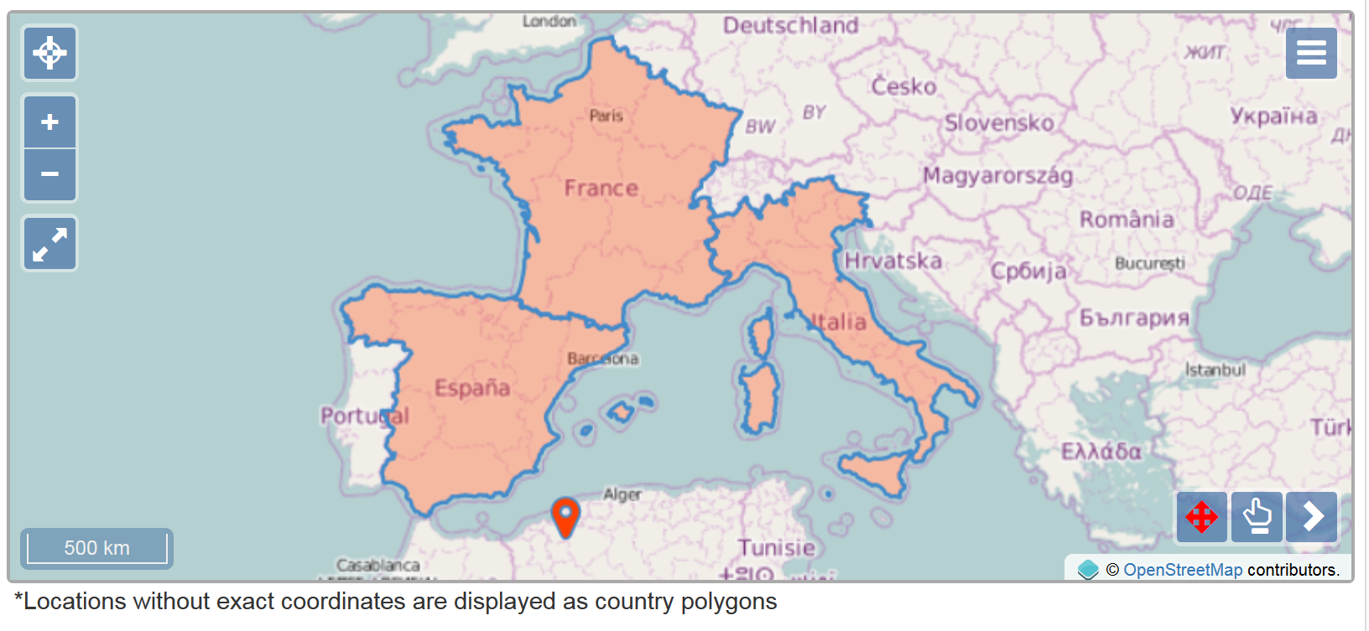
SFIGURE 1. Distribution map of Tricholoma caligatum sensu stricto, showing the Algerian origin of our sample. Map from Unite database (http://dx.doi.org/10.15156/BIO/SH221552.07FU), using OpenStreetMap (http://www.openstreetmap.org/copyright) © OpenStreetMap contributors.

